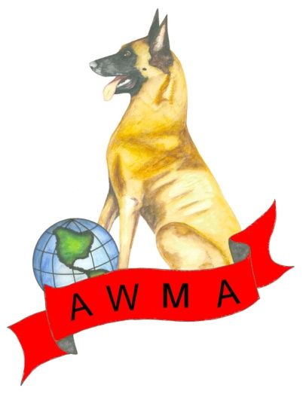
APPLICATION TO RECORD A WORKING DOG TITLE

American Working Malinois Association
In association with the American Belgian Malinois Club, the Belgian Sheepdog Club of America, and the American Kennel Club

As per restrictions from the AKC only AKC registered Belgian Malinois and Belgian Sheepdogs are eligible to record titles through this program, and titles must have been earned at an AWMA event
Please complete this form and send to the address below. In addition, complete and submit AKC’s application (http://www.akc.org/pdfs/events/working_dog_sport/application_to_record.pdf) and send it directly to them. Eligible titles for recording and other information can be found here: http://www.akc.org/events/working_dog_sport.
Owner name: _________________________________________________________________________
Address: _____________________________________________________________________________
Phone: _______________________________ Email:__________________________________________
Dog’s registered name: __________________________________________________________________
Sire: __________________________________________________________________________
Dam: _________________________________________________________________________
Dog’s AKC registration number: ___________________________________________________________
Title to be recorded (list highest title only):_____ _____________________________________________
Date title earned: ______________________________________________________________________
AWMA host club offering the trial: ________________________________________________________
PLEASE PROVIDE THE FOLLOWING ALONG WITH THIS FORM
- A complete and clear copy of the dog’s scorebook with a distinct highlight of the trial where the title was obtained
- A check for $25 made out to the AWMA
MAIL TO: Donna McGinnis email: dgmfelise@yahoo.com
P.O. Box 72738
Phoenix, AZ 85050

